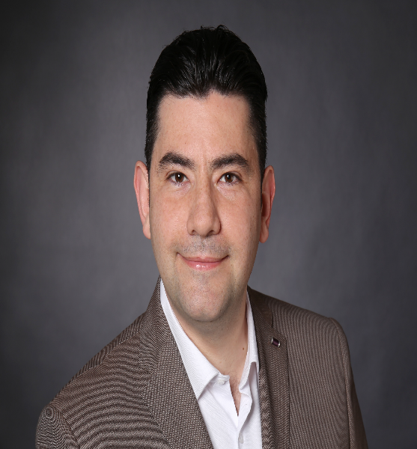

My short profile

- Bachelor degree in Management Information Systems and postgraduate diploma in Operations and Supply Chain Management from Liverpool University

- International experience in Procurement & Supply Chain Management

- SAP Material Management & Distribution (MM, SD)

- Excellent command of English and good in German

- International Import & Export knowledge

- Digital data & SAP integration experience

Personal data

Born in 27.03.1983
In Damascus/Syria
Married

Preparation of the professional entry into Germany

03/2019 – 04/2019 SAP modules SD and MM - with Certificate
Alfatraining, Aachen

11/2018 – 02/ 2019 German language course Intensive - B2 certificate
Alfatraining, Aachen

05/2015 – 07/2019 Postgraduate diploma Degree in Operations and Supply Chain Management
Liverpool University, United Kingdom
Practical experience

05/2019 – Now Robert Half GmbH
Strategic Procurement- Fixed Project – Lyondellbasell, (Wessling,
Germany) 02/2019-Now
- Support in Managing Global Tail Spend of A. Schulman acquisition Program.
- Support Global Procurement team in SAP Integration process (HS codes, Country of Origins, ISO Certificates, POs Conversion and Purchase requisitions for LYB Europe).

Digital Data Transformation- Fixed Project – Lyondellbasell, (Kerpen,
Germany) 10/2019-01/2020
- Support the business in the upfront process design and data work in preparation for SAP integration project between A. Schulman and Lyondellbasell.

Fair Trade Logistics Coordinator- Fixed Project – MBS Logistics,
(Cologne, Germany) 05/2019-09/2019
- Quotation, order acceptance and transport organization of the shipments by air, sea and land freight to all trade fair locations in Germany and Europe.
- Customs clearance for trade show shipments (imports / exports).
- Acquisition of new customers and support of existing customers.

03/2018 – 09/2018 Deutsche Telekom AG, Bonn/Deutschl
Global Network Capacity Strategic Procurement- Fixed Contract.
- Supplier’s evaluation and quotations analysis.
- Contract management.
- Claim reports.
11/2017 – 03/2018 Robert Half GmbH
Supply Chain Coordinator- Fixed Project – DHL Automotive Supply
Chain, Köln/Deutschland
- Responsible for coordinating the logistical operations and supply of Ford durable containers between Ford plants and Ford Suppliers in East Europe and Turkey.

06/2014 – 10/2015 Madar Aluminum, Gebze/Turkey
Supply Chain and Logistics Senior-Officer
- Responsible for all Inbound Logistics Operations in three different operational sites L’Aquila in Italy, Corlu and Gebze in Turkey.
- Supplying Paints, Solvents, Aluminium and Packing materials from local and foreign markets.
- Managing bonded warehouse operations.
- Responsible for paints and aluminium quality and claim issues.

01/2013 – 05/ 2014 Madar Coil Coating Europe, L’Aquila/Italy
Supply Chain and Logistics Senior-Officer
- Key Member in Start-Up phase for MCCE in Italy as a new project.
- Applying Supply Chain technics to identify the safety stock and the Re-Order- Point for consumables and raw materials.
- Responsible for all inbound Logistics Operations.
- Daily inventory controls for hundreds of different products.
- Raising the efficiency of MCC group through developing a new system (graphical reporting system) as a new idea to improve the communication methods and coordinating channels with other group sites, offices and departments such as logistics, planning, and sales.
- Responsible for weekly reports to Managing Director of MCC Group.
- A representative of Logistics and Supply Chain Dept. for ISO audit.

08/2010 –12/2012 Madar Coil Coating, Damascus/Syria
Foreign Purchasing Senior Officer
- Fixing LME (London Metal Exchange) price with different aluminium suppliers.
- Purchasing aluminum coils and raw materials for paint production such as additives, solvents, resins, pigments, pastes, and titanium.

Education

2003 – 2009 Bachelor of Science Degree
Management Information System
University of Kalamoon, Syria.

2015 – 2019 Postgraduate Diploma Degree- Four years study program
Operations and Supply Chain Management
University of Liverpool, United Kingdom.
Other Skills
Foreign languages
- German – good
- English – Excellant

IT Skills
- Microsoft Office Suite
- SAP Module MM and SD
- Ariba ERP System

Obadah Tarkji

